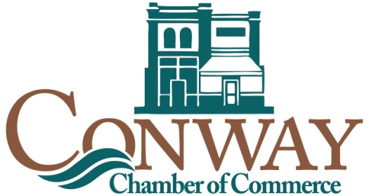
Annual Meeting & Awards Celebration
Thursday, October 19, 2017

Sponsor Commitment Form

Please complete the following and return to the Chamber of Commerce office at P.O. Box 831, Conway, SC 29528 or fax to 843-248-0003, no later than Friday, September 29, 2017.

____Yes, I/we agree to serve as a Sponsor in the amount of $2500 for the Conway Chamber of Commerce 2017 Annual Meeting and Awards Celebration.

____Yes, I/we agree to serve as a Patron in the amount of $1000 for the Conway Chamber of Commerce 2017 Annual Meeting and Awards Celebration.

____Yes, I/we agree to serve as a Benefactor in the amount of $500 for the Conway Chamber of Commerce 2017 Annual meeting and Awards Celebration.

____Yes, I/we agree to serve as a Contributor in the amount of $250 for the Conway Chamber of Commerce 2017 Annual meeting and Awards Celebration.

___Enclosed is my/our check in the amount of _______ made payable to the Conway Chamber of Commerce.

___Please bill me/us.

___Please bill my credit card: Credit Card #__________ ________________
Expiration date: ________________________

Please list me/our company as follows on all appropriate materials, signs and press releases as follows.

_______________________________________________________________ (Please Print)

Signed: _______________________________ Date: ___________________

THANK YOU FOR YOUR SUPPORT AND KIND GENEROSITY.

